# Creating the Table ‘XXBCM_ORDER_MGT’

To create table ‘XXBCM_ORDER_MGT’, we just need to execute the script ‘DB_Prequisite.sql’ which was provided.

We can just execute the script via SQLPlus or on Oracle SQL itself and commit.

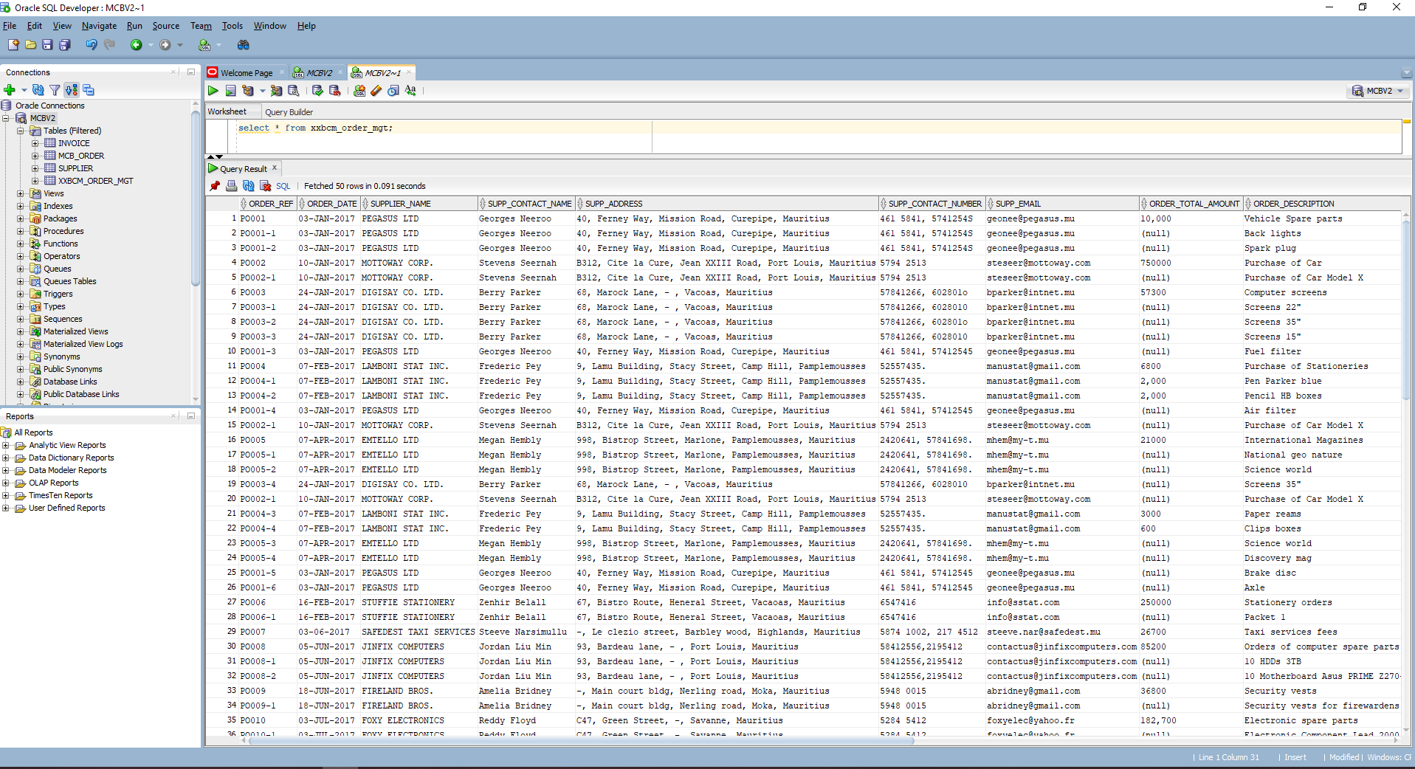

# Creating necessary Tables, Columns, Data Types and Constraints

## Tables

Three tables need to be created:

* SUPPLIER
* INVOICE
* MCB_ORDER

But since, the table supplier doesn’t have any primary key, only 2 tables will be created

* INVOICE
* MCB_ORDER

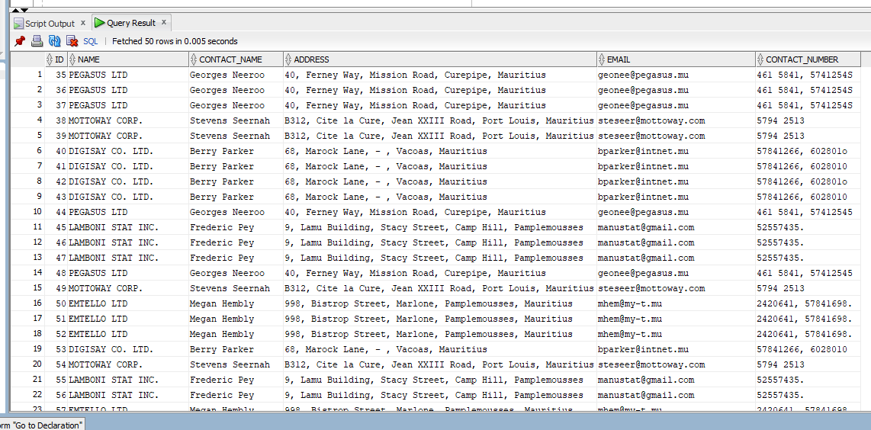

## Database Schema

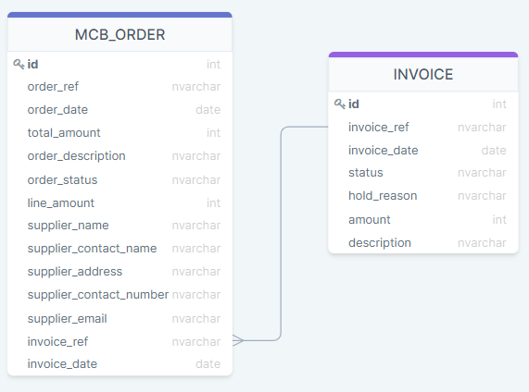

## Columns, data types and constraints

INVOICE:

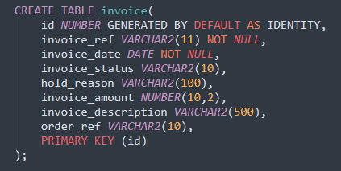

MCB_ORDER:

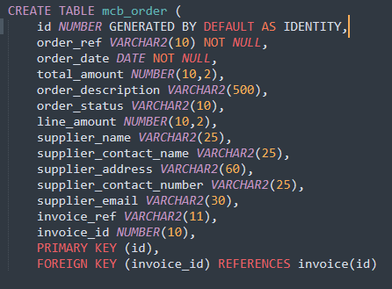

Note: The field id in all the columns are primary key and also generated automatically by the system.

# Migration Process

## INVOICE



Note: I had an issue converting invoice_amount from string to number as some data contained strings. So, I removed all the characters and left all numbers.

It’s those 2 records causing problem:

* select invoice_amount,order_ref,invoice_reference from xxbcm_order_mgt where order_ref = 'PO001-1' and invoice_reference = 'INV_PO001';

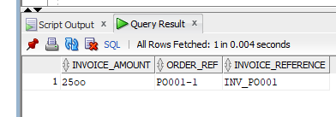

* select invoice_amount,order_ref,invoice_reference from xxbcm_order_mgt where order_ref = 'PO004-2' and invoice_reference = 'INV_PO004';

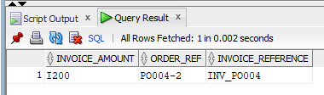

Normally, at work, we have to confirm if those values are really correct or not. For example, the first one could be 2500 and the second one 1200. If It was an error, we should correct these 2 amounts.

## MCB_ORDER



See attached script.

# Question 4



See attached script.

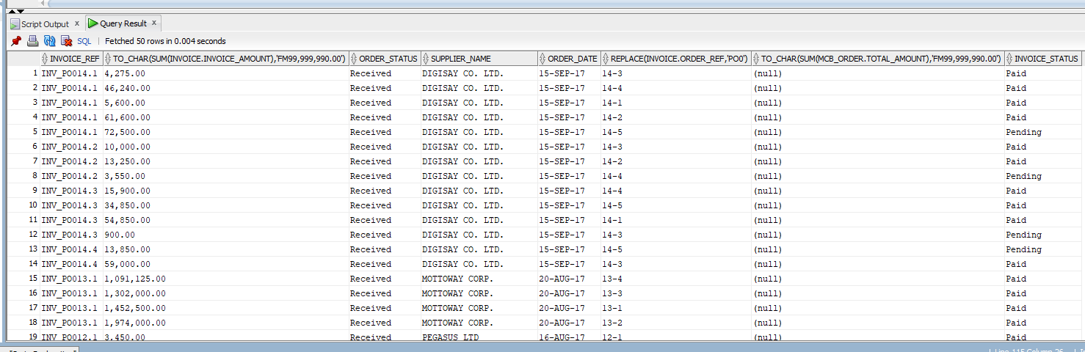

# Question 5

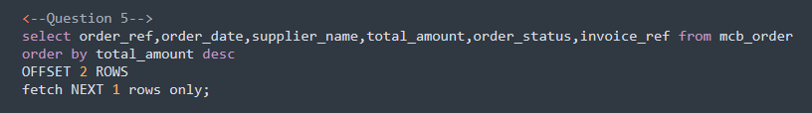

See attached script.

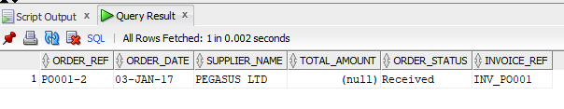

# Question 6



See attached script.

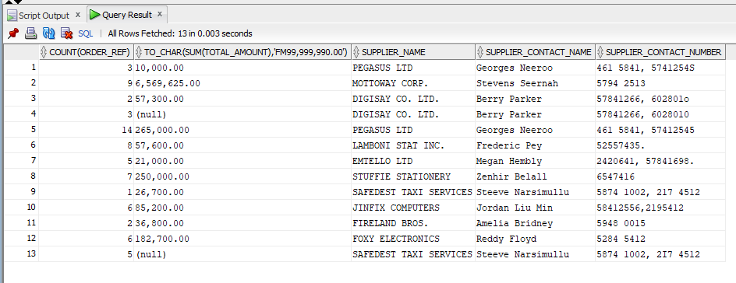

# Difficulties encountered

* Data not consistent. Normally, the supplier should have unique email and contact number so that we may be able to identify a proper primary key.
* Order_ref and order_date should be primary key but data does not allow it. (unique constraint violated)
* I had difficulty of finding primary key for the tables.